GENERAL description

## **xMotion P1**

**xMotion – Prototype 1 (P1)**

**P1** measures voluntary movements of the face and translates them into mouse or keyboard commands sent via Bluetooth Low Energy (BLE) to wirelessly communicate with any PC, iOS or Android device.

**P1** consists of a light headset which incorporates up-to six articulated legs (three legs per side) that can conform the contour of any face and capture voluntary movements from any muscle, and a control box housing an open source Arduino-compatible Bluefruit nRF52 Feather board that is automatically recognized as a human-interface device (HID). **P1** transmits wirelessly preprogramed keyboard or mouse HID commands to any PC, iOS or Android device via BLE. The headset and the control box are connected via two cables relaying sensor signals from both sides of the face to the Bluefruit nR52 board.

The articulated headset legs are made of 3D printed modular Lego-like pieces with ball joints allowing the required adjustments of length and direction to fit any face contour. The modular design further facilitates replacements if needed. At the end of each leg, a probe incorporates a flexible sensor that, when in contact with the face, captures voluntary movements. The signals from the probes are relayed to an electronic hub (one per side) which amplifies and conditions the signals before sending them to the controller box.

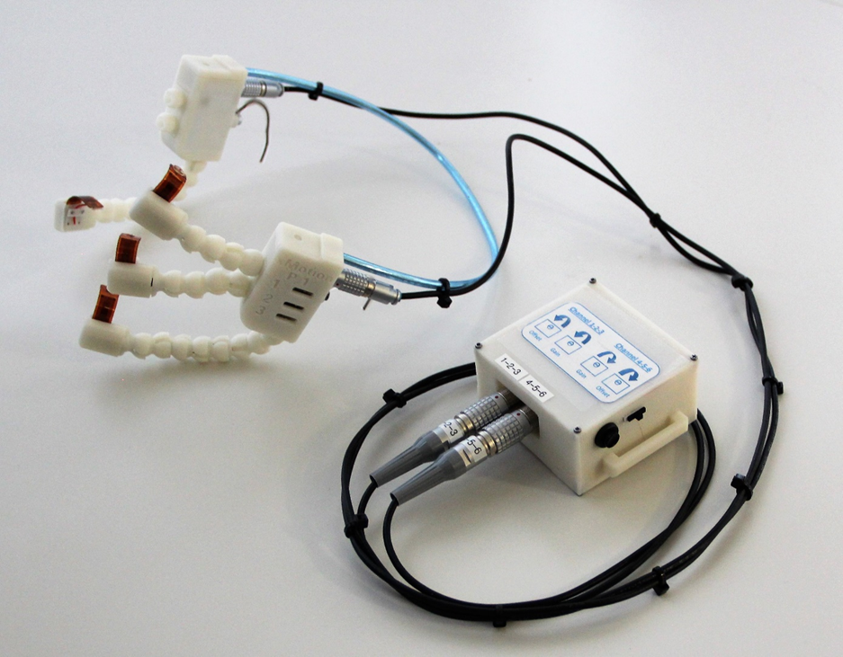

**P1 components. (1)** Headset**; (2)** Control box; **(3)** Cablesconnecting headset and control box (two, left and right); **(4)** Electronic hubs (two, left - right); **(5)** Legs (up-to six, three left - three right); **(6)** Probes (up-to six); **(7)** Flexible sensors (up-to six).

Assembly description

## **xMotion P1**

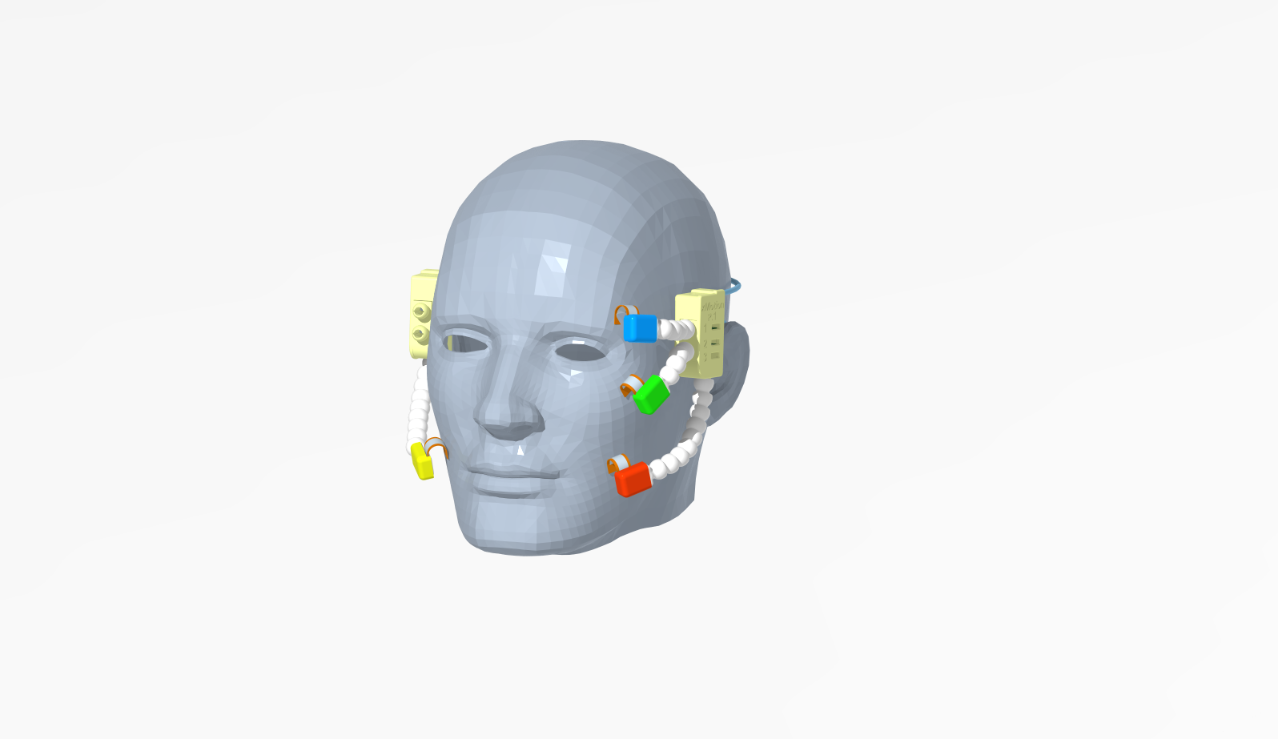

## Mechanical parts list

|  |  |  |  |
| --- | --- | --- | --- |
| Part description | Assembly | Quantity | Link |
| Fillister screw M1.6x6 | Probe sub-assembly | 24 | [M1.6x6](https://www.tme.eu/mt/en/details/b1.6x6_bn384/bolts/bossard/1945130/) |
| Flat wire 4 contacts - 30 mm | Probe sub-assembly | 4 | [98267-0701](https://www.mouser.fr/ProductDetail/Molex/98267-0701?qs=sGAEpiMZZMvyL%252B65tEJ%2FLxIhByPU5QLk94qb8N3W9RU%3D) |
| Flat wire 4 contacts - 50 mm | Probe sub-assembly | 4 | [686704050001](https://www.mouser.fr/ProductDetail/Wurth-Elektronik/686704050001?qs=sGAEpiMZZMvyL%252B65tEJ%2FLzbohXnYKf05lKQ9ZE99dgR7JGB0QrF2rA%3D%3D) |
| Flat wire 4 contacts - 76 mm | Probe sub-assembly | 2 | [15167-0704](https://www.mouser.fr/ProductDetail/Molex/15167-0704?qs=sGAEpiMZZMvyL%252B65tEJ%2FL8uh7MrRs2hyzHlebbwcAK4%3D) |
| Allen screw M2.5x6 | Hubs sub-assembly | 2 | [M2.5x6](https://www.tme.eu/mt/en/details/b2.5x6_bn11/bolts/bossard/1011871/) |
| Connector 5 pos. + nut and washer | Hubs sub-assembly + Control box sub-assembly | 4 | [EGG.00.305.CLL](https://ch.farnell.com/fr-CH/lemo/egg-00-305-cll/connecteur-circulaire-embase-5pos/dp/2442842) |
| Nuts M2.5 | Control box sub-assembly | 4 | [Nuts](https://www.tme.eu/mt/en/details/b2.5_bn124/nuts/bossard/m2-5-bn124/) |
| Spacer M2.5x10 | Control box sub-assembly | 4 | [Spacer](https://www.tme.eu/mt/en/details/tff-m2.5x10_dr1212/metal-spacers/dremec/1212x10/) |
| Flat screw M2.5x6 | Control box sub-assembly | 4 | [M2.5x6](https://www.tme.eu/mt/en/details/b2.5x6_bn20/bolts/bossard/1480278/) |
| Kapton sheet of 125 µm thickness | Probe sub-assembly | 1 | [Kapton](https://www.dupont.com/content/dam/dupont/products-and-services/membranes-and-films/polyimde-films/documents/DEC-Kapton-general-specs.pdf) |
| Kapton tape of 25 µm thickness | Probe sub-assembly | 1 | [Kapton tape](https://fr.farnell.com/pro-power/ppc220/ruban-kapton-marron-25mmx33m/dp/2061299) |
| P400 sandpaper | Probe sub-assembly | 1 | [A02010](https://fr.farnell.com/3m/a02010/sheet-230x280mm-p400/dp/1495822?st=papier%20de%20verre%20p400) |
| Double tape Spandex of 50 µm thickness | Probe sub-assembly | 1 | [Spandex](https://shop.spandex.com/fr_CH/outils-de-masquage-et-accessoires-adhesive-tapes-fasteners-rubans-adhesifs-double-face-rubans-adhesifs-double-face/scotch-8132-le-transfer-sans-support-en-feuilles/p/bxn?q=%3Aname-asc) |
| Steel wire – 2 mm of diameter | General + Hubs sub-assembly | 30 cm | [Steel wire](https://www.jumbo.ch/fr/fil-de-fer-galvanise-15597?sku=1344551) |
| Silicone pipe – 2.5 mm of internal diameter and 4 mm of outside diameter | General + Hubs sub-assembly | 30 cm | [Silicone pipe](https://www.amazon.in/SLB-Works-Resistant-Silicone-Rubber/dp/B07G81HRD3) |

## Electronic parts list

|  |  |  |  |
| --- | --- | --- | --- |
| Part description | PCB | Quantity | Link |
| Operational Amplifier | PCB channel 1 to 3 | 3 | [LT1789-1](https://www.analog.com/media/en/technical-documentation/data-sheets/1789fc.pdf) |
| Trimmer 2 kOhm 250 mW | PCB channel 1 to 3 | 3 | [3224J-1-202E](https://www.distrelec.ch/Web/Downloads/_t/ds/3224-series_eng_tds.pdf?pid=16400642) |
| Trimmer 100 kOhm 250 mW | PCB channel 1 to 3 | 3 | [3224J-1-104E](https://www.distrelec.ch/Web/Downloads/_t/ds/3224-series_eng_tds.pdf?pid=16400641) |
| 10 kΩ resistors | PCB channel 1 to 3 | 6 | [SMD resistors](https://www.distrelec.ch/Web/Downloads/_t/ds/rnd_smd_resistors_eng_tds.pdf?pid=30069020) |
| 120 Ω resistors | PCB channel 1 to 3 | 6 | [SMD resistors](https://www.distrelec.ch/Web/Downloads/_t/ds/rnd_smd_resistors_eng_tds.pdf?pid=30069020) |
| Backlock Connector (1.0 pitch, 4 pins, Dual Contact) | PCB channel 1 to 3 + PCB Connection | 12 | [XF3M](https://www.mouser.ch/datasheet/2/307/XF3M_0813-1190174.pdf) |
| Linear voltage regulator 1-5.5 V SOIC-8 | Perpendicular PCB | 1 | [LP3878MR-ADJ/NOPB](http://www.ti.com/lit/ds/symlink/lp3878-adj.pdf) |
| 0.15 µF Capacitors | Perpendicular PCB | 2 | [SMD capacitors](https://www.distrelec.ch/Web/Downloads/_t/ds/CER_ENG_KIT_30_eng_tds.pdf?pid=30016803) |
| 10 nF capacitor | Perpendicular PCB | 1 | [SMD capacitor](https://www.distrelec.ch/Web/Downloads/_t/ds/CER_ENG_KIT_30_eng_tds.pdf?pid=30016803) |
| 4.7 µF capacitor | Perpendicular PCB | 1 | [SMD capacitor](https://www.distrelec.ch/Web/Downloads/_t/ds/CER_ENG_KIT_30_eng_tds.pdf?pid=30016803) |
| 1 kΩ resistor | Perpendicular PCB | 1 | [SMD resistors](https://www.distrelec.ch/Web/Downloads/_t/ds/rnd_smd_resistors_eng_tds.pdf?pid=30069020) |
| 100 kΩ resistor | Perpendicular PCB | 1 | [SMD resistors](https://www.distrelec.ch/Web/Downloads/_t/ds/rnd_smd_resistors_eng_tds.pdf?pid=30069020) |
| Headers 1.27x1.27mm | Perpendicular PCB | 1 | [20021111-00006T4LF](https://www.farnell.com/cad/2562126.pdf?_ga=2.75548885.1501753192.1579255787-455629369.1579255787&_gac=1.144968960.1579256589.EAIaIQobChMIq9yInLWK5wIVB-J3Ch1sUAZ0EAAYASAAEgKjOvD_BwE) |
| Wire Housings 1.27x1.27mm | Perpendicular PCB | 1 | [20021311-00006T4LF](http://www.farnell.com/datasheets/2374175.pdf?_ga=2.17351161.1501753192.1579255787-455629369.1579255787&_gac=1.36987924.1579256890.EAIaIQobChMIqMz1rLaK5wIVC9HeCh1tSASOEAAYASAAEgLc6vD_BwE) |
| Bluefruit LE – nRF52 | Main PCB | 1 | [Adafruit Feather nRF52 Bluefruit LE](https://www.distrelec.ch/Web/Downloads/_t/ds/Adafruit_Bluefruit_NRF52_eng_tds.pdf?pid=30129225) |
| 10 kΩ resistors | Main PCB | 1 | [SMD resistors](https://www.distrelec.ch/Web/Downloads/_t/ds/rnd_smd_resistors_eng_tds.pdf?pid=30069020) |
| Batteries LIPO 420mAh 3.7V | Main PCB | 1 | [rechargable battery](https://www.distrelec.ch/Web/Downloads/_t/ds/ICP402050PR_eng_tds.pdf?pid=30158711) |
| Push-button opaque | Main PCB | 1 | [push button](https://www.distrelec.ch/Web/Downloads/he/et/110107_eng_datasheet.pdf?pid=13552218) |
| Supply Switch | Main PCB | 1 | [NK236](https://www.mouser.fr/ProductDetail/Apem/NK236?qs=sGAEpiMZZMtHXLepoqNyVUerHPz7yx8Ij1jvu1PfMGI%3D) |

## Printed parts list

|  |  |  |  |
| --- | --- | --- | --- |
| Part description | Assembly | Quantity | Part name |
| Ball joints | General | mini. 25 | ball\_joints.stl |
| Protective cover probe | Probe sub-assembly | 4 | protective\_cover\_probe.stl |
| Ball joints left (female) | Probe sub-assembly | 3 | ball\_joints\_left.stl |
| Ball joints right (female) | Probe sub-assembly | 3 | ball\_joints\_right.stl |
| Left Hub box | Hubs sub-assembly | 1 | hub\_box\_left.stl |
| Left Hub box cover | Hubs sub-assembly | 1 | hub\_cover\_box\_left.stl |
| Right Hub box | Hubs sub-assembly | 1 | hub\_box\_right.stl |
| Right Hub box cover | Hubs sub-assembly | 1 | hub\_cover\_box\_right.stl |
| Head support fixing cover | Hubs sub-assembly | 2 | cover\_support\_head.stl |
| Ball joint connector (male) : channel 1 and 2 | Hubs sub-assembly | 2 | ball\_joint\_connector\_12.stl |
| Ball joint connector (male) : channel 3 | Hubs sub-assembly | 2 | ball\_joint\_connector\_3.stl |
| Top cover box | Control box sub-assembly | 1 | top\_cover\_control\_box.stl |
| Middle box | Control box sub-assembly | 1 | middle\_control\_box.stl |
| Bottom cover box | Control box sub-assembly | 1 | bottom\_cover\_control\_box.stl |

## General assembly

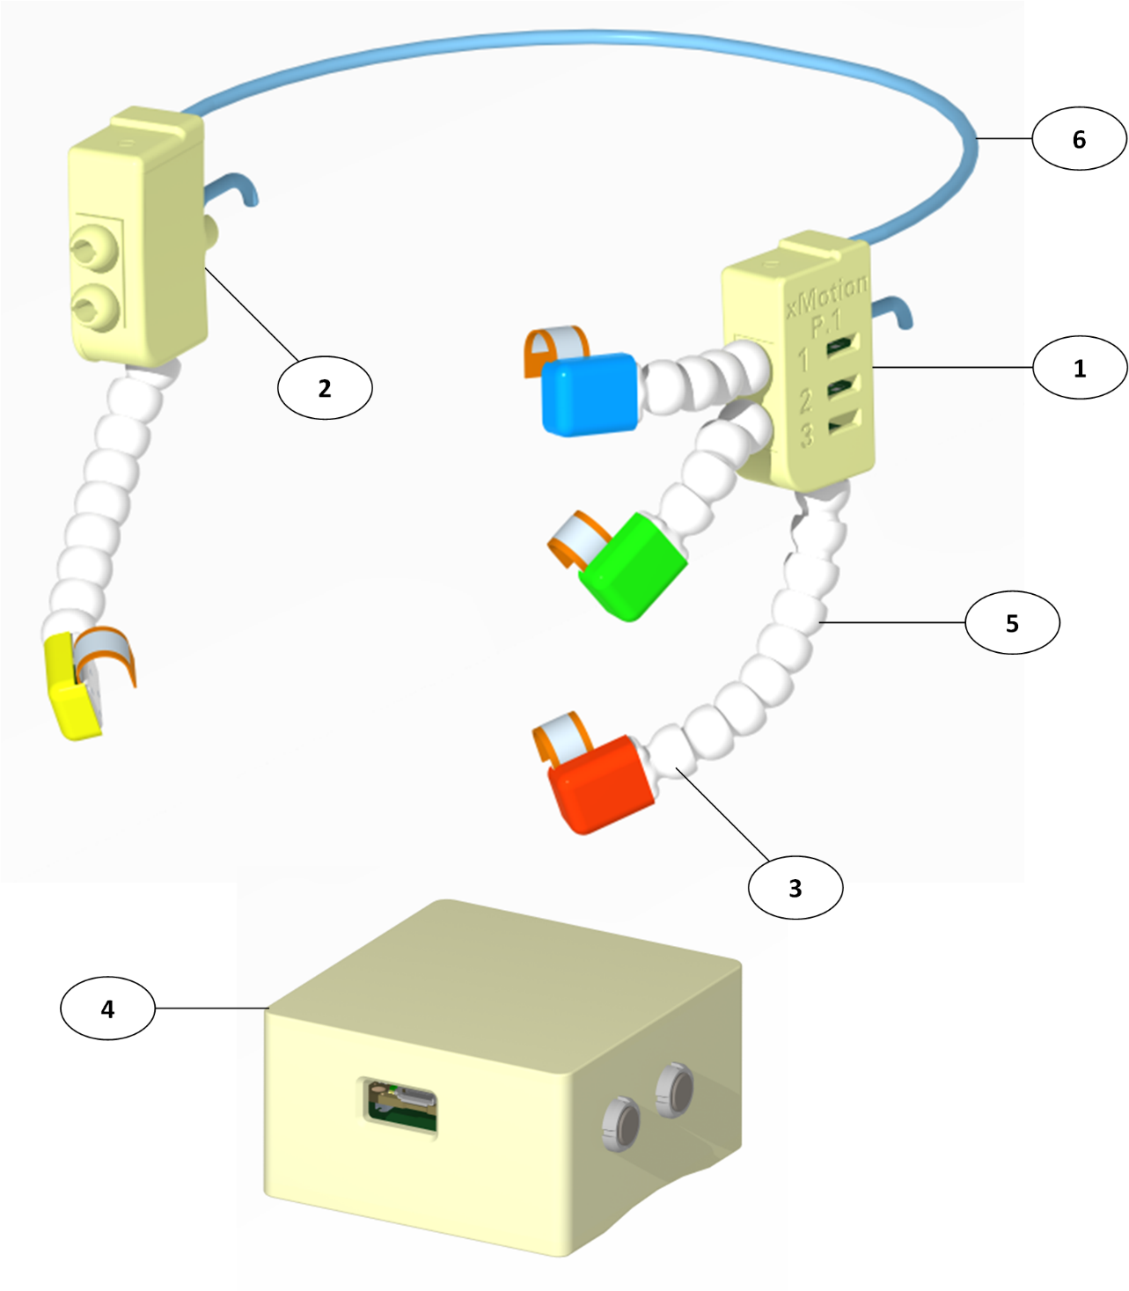

|  |  |  |
| --- | --- | --- |
| N° | Part description | Quantity |
| 1 | Left Hub sub-assembly | 1 |
| 2 | Right Hub sub-assembly | 1 |
| 3 | Probe sub-assembly | 1 |
| 4 | Control box sub-assembly | 1 |
| 5 | Ball joints | 20 |
| 6 | Head support | 1 |
| 7 | Signal cables | 2 |

## Probe sub-assembly

|  |  |  |  |  |  |  |  |  |  |  |  |  |  |  |  |  |  |
| --- | --- | --- | --- | --- | --- | --- | --- | --- | --- | --- | --- | --- | --- | --- | --- | --- | --- |
| C:\Users\quentin.praz\AppData\Local\Microsoft\Windows\INetCache\Content.Word\probes_3.png | |  |  | | --- | --- | | N° | Part description | | 1 | Protective cover probe | | 2 | Fillister screw M1.6x6 (4x) | | 3 | PCB probe connection | | 4 | Backlock Connector | | 5 | Flat wire 4 contacts | | 6 | Ball joints left (female) | | 7 | Sensor (flexible substrate + 2 strains gauges) | |
|  | |

## Sensor sub-assembly

The sensor is designed to be sufficiently flexible to detect facial movements. The sensitive element is a flexible piece that bends during the contraction of one or more muscles of the face. Two strain gauges fixed to a substrate translate the mechanical deformation into an electrical signal. The steps to fabricate the sensor are described below.

### Fabrication process

|  |  |  |
| --- | --- | --- |
| Step | Description | Materials needed |
| 1 | Laser cutting the substrate design on a Kapton sheet. | * Laser cutter machine * Kapton sheet of 125 µm thickness * Substrate design: |
| 2 | Sand the surface with at least a P400 micro-grain sandpaper. Clean both sides of the substrate with Isopropanol. | * P400 sandpaper * Bottle of Isopropanol |
| 3 | Place the adhesive double-sided tape on each side of the substrate in the designated rectangle below. | * Double tape Spandex of 50 µm thickness * Scalpel or fine cutter |

|  |  |  |
| --- | --- | --- |
| 4 | Attach the strain gauges on top of the two adhesive tapes and put a weight on it, for at least 1 hour, until the adhesive has bonded well. | * 2 Strain gauges HBM of 120 Ω * A tweezer to manipulate the strain gauges * Weight of ≥ 5 Kg |
| 5 | Recover the substrate and strain gauges with Kapton tape on each side as shown below: | * Kapton tape of 25 µm thickness * Scalpel or fine cutter |
| 6 | Place the substrate on bottom of the PCB probe connection. First solder the top resistance to the PCB, and then solder the bottom resistance trough the two little cut rectangles of the substrate. | * PCB probe connection with the zero force connector mounted * Soldering station with tin wire * A tweezer to manipulate the strain gauges |

## Left Hub sub-assembly

|  |  |  |  |  |  |  |  |  |  |  |  |  |  |  |  |  |  |  |  |  |  |  |  |  |  |  |  |
| --- | --- | --- | --- | --- | --- | --- | --- | --- | --- | --- | --- | --- | --- | --- | --- | --- | --- | --- | --- | --- | --- | --- | --- | --- | --- | --- | --- |
| C:\Users\quentin.praz\AppData\Local\Microsoft\Windows\INetCache\Content.Word\box_left_2.png | |  |  | | --- | --- | | N° | Part description | | 1 | Left Hub box | | 2 | Head support fixing cover | | 3 | Left Hub box cover | | 4 | Connector 5 pos. + nut and washer | | 5 | Ear support | | 6 | Allen screw M2.5x6 (1x) | | 7 | Ball joint connector (male) :  channel 1 and 2 | | 8 | Ball joint connector (male) : channel 3 | | 9 | Flat wire 4 contacts (3x) | | 10 | Backlock Connector (3x) | | 11 | PCB channel 1 to 3 | | 12 | Perpendicular PCB | |
|  | |

|  |  |
| --- | --- |
| **N° 11 : PCB channel 1 to 3** |  |
|  | |  |  | | --- | --- | | N° | Part description | | 1 | 10kΩ resistors (2x) | | 2 | Operational Amplifier | | 3 | welding tracks | | 4 | 120Ω resistors (2x) | | 5 | Trimmer 100 kΩ 250 mW | | 6 | Trimmer 2 kOhm 250 mW | | 7 | Backlock Connector | |

|  |  |
| --- | --- |
| **N° 12 : Perpendicular PCB** |  |
|  | |  |  | | --- | --- | | N° | Part description | | 1 | 4.7µF capacitor | | 2 | 0.15µF Capacitor | | 3 | 10nF capacitor | | 4 | 0.15µF Capacitor | | 5 | 100kΩ resistor | | 6 | 1kΩ resistor | | 7 | Headers 1.27x1.27mm | | 8 | Linear voltage regulator 1-5.5 V SOIC-8 | | 9 | welding tracks | |

## Control box sub-assembly

|  |  |  |  |  |  |  |  |  |  |  |  |  |  |  |  |  |  |  |  |  |  |  |  |  |  |  |  |  |  |  |  |
| --- | --- | --- | --- | --- | --- | --- | --- | --- | --- | --- | --- | --- | --- | --- | --- | --- | --- | --- | --- | --- | --- | --- | --- | --- | --- | --- | --- | --- | --- | --- | --- |
|  | |  |  | | --- | --- | | N° | Part description | | 1 | Top cover box | | 2 | Supply switch | | 3 | Push button | | 4 | Middle box | | 5 | Connector 5 pos. + nut and washer (2x) | | 6 | Bluefruit LE – nRF52 (Arduino-compatible + Bluetooth Low Energy) | | 7 | Headers 16 pos. | | 8 | Headers 12 pos. | | 9 | Nuts M2.5 (4x) | | 10 | Main PCB | | 11 | Batteries LIPO 420mAh 3.7V | | 12 | Spacer M2.5x10 (4x) | | 13 | Bottom cover box | | 14 | Flat screw M2.5x6 (4x) | |
|  |  |
|  | |

|  |  |
| --- | --- |
| **N° 10 : Main PCB** |  |
|  | |  |  | | --- | --- | | N° | Part description | | 1 | 10kΩ resistor | | 2 | Connector pins for right side | | 3 | Connector pins for left side | | 4 | Connector pins for battery | | 5 | Connector pins for push button | | 6 | Bluefruit LE – nRF52 (Arduino-compatible + Bluetooth Low Energy) | | 7 | Batteries LIPO 420mAh 3.7V | |

## PCBs Overview

## 

## Ear and Head supports

The ear and head supports are made of steel wire of 2 mm diameter. The steel wire is shaped using pliers to adapt to ears and head morphology. Then, the steel wire is inserted into a flexible silicone-based tubing to improve the comfort of the wearable headset.

|  |  |
| --- | --- |
| **N° 5 from the Hub sub-assembly :**  **Ear Support** | **N° 6 from the General assembly :**  **Head Support** |
|  |  |